Website Report for smiledentalandimplantcentre.com



The HOTH

111 2nd Ave NE, Suite 1500, St. Petersburg, FL 33701

877-720-4684

[support@thehoth.com](mailto:support@thehoth.com)

[thehoth.com](http://thehoth.com/)

This report grades your website based on the strength of various SEO factors such as On Page Optimization, O Page Links, Social and more. The overall Grade is on a A+ to F- scale, with most major, industry leading websites in the A range. Improving your grade will generally make your website perform better for users and rank better in search engines. There are recommendations for improving your website at the bottom of the report. Feel free to reach out to us if you’d like us to help with improving your website’s SEO!

Audit Results for smiledentalandimplantcentre.com



**B**

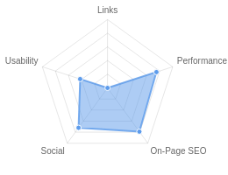**Your page could be better**

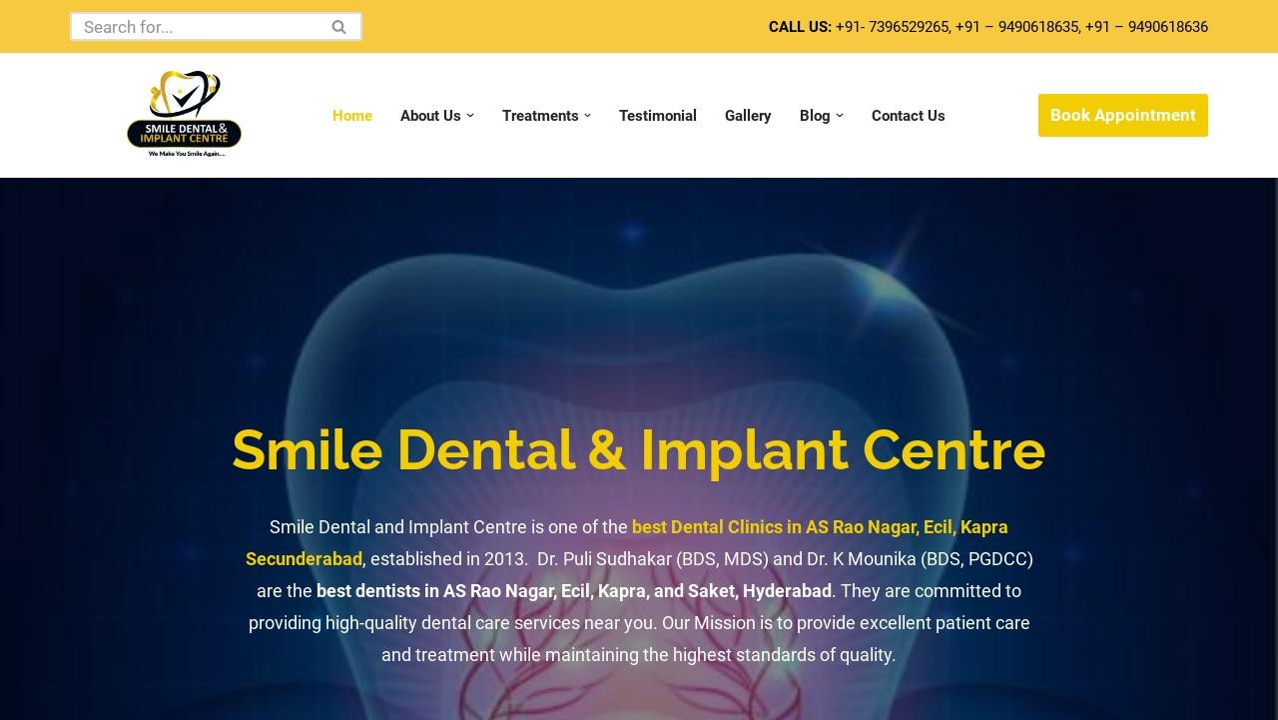

Recommendations: 16



**A**



**F**



**C**



**A-**



**A-**

On-Page SEO

Links

Usability

Performance

Social

Recommendations

# Execute a Link Building Strategy

Links

High Priority

**Reduce length of title tag (to between 10 and 70 characters)**

On-Page SEO

Medium Priority

# Update Link URLs to be more human and Search Engine readable

Links

Low Priority

**Add Alt attributes to all images**

On-Page SEO

Low Priority

# Increase page text content

On-Page SEO

Low Priority

**Optimize your images to reduce their file size**

Performance

Low Priority

# Optimize your page for Mobile PageSpeed Insights

Usability

Low Priority

**Optimize your page for Desktop PageSpeed Insights**

Usability

Low Priority

# Implement an analytics tracking tool

On-Page SEO

Low Priority

**Increase your YouTube channel subscribers**

Social

Low Priority

# Setup & Install a Facebook Pixel

Social

Low Priority

**Remove inline styles**

Performance

Low Priority

# Remove iFrames

Usability

Low Priority

**Add business address and phone number**

Other

Low Priority

# Add Local Business Schema

Other

Low Priority

**Create Google Business Profile**

Other

Low Priority

On-Page SEO Results

# Your On-Page SEO is good



**A**

Your page is mostly optimized for On-Page SEO performance. On-Page SEO is important to ensure Search Engines can understand your content appropriately and help it rank for relevant keywords. You can continue to improve your page by ensuring HTML Tag Content is completed correctly and text content is well aligned with chosen keywords.

# Title Tag

You have a title tag, but ideally it should be shortened to between 10 and 70 characters (including spaces).

Smile Dental & Implant Centre | Best Dental Clinic In Ecil, AS Rao Nagar, Kapra, Hyderabad Length : 94

Title tags are very important for search engines to correctly understand and categorize your content.

# Meta Description Tag

Your page has a meta description of optimal length (between 70 and 160 characters).

Smile Dental & Implant Centre is the best dental clinic in Ecil, AS Rao Nagar, Kapra, Hyderabad with the best dentists for painless dental treatment.

Length : 153

# SERP Snippet Preview

This illustrates how your page may appear in Search Results. Note, this is intended as a guide and Search Engines are more frequently generating this content dynamically.

https://smiledentalandimplantcentre.com ⋮

Smile Dental & Implant Centre

Smile Dental & Implant Centre is the best dental clinic in Ecil, AS Rao Nagar, Kapra, Hyderabad with the best dentists for painless dental ...

# Hreflang Usage

Your page is not making use of Hre ang attributes.

# Language

Your page is using the lang attribute. Declared: en-US

# H1 Header Tag Usage

Your page has a H1 Tag.

# H2-H6 Header Tag Usage

Your page is making use multiple levels of Header Tags.

Header Tag Frequency

H2 14

H3 19

H4 9

H5 0

H6 1

# Keyword Consistency

Your page's main keywords are distributed well across the important HTML tags.

Individual Keywords

Keyword Title Meta Description

Tag

Headings Tags Page Frequency

dental    7

smile    5

treatments    4

implant    4

centre    4

now    3

appointment    3

make    2

Phrases

Phrase Title Meta Description

Tag

smile dental    4

Headings Tags Page Frequency

implant centre    4

dental implant    2

rao nagar    2

nagar ecil    2

ecil kapra    2

smile dental implant    2

dental implant centre

   2

# Amount of Content

Your page has a low volume of text content which search engines can interpret as 'thin content'.

Word Count: 195

It has been well researched that higher text content volumes are related to better ranking ability in general.

# Image Alt Attributes

You have images on your page that are missing Alt attributes.

We found 39 images on your page and 16 of them are missing the attribute.

Alt attributes are an often overlooked and simple way to signal to Search Engines what an image is about, and help it rank in image search results.

# Canonical Tag

Your page is using the Canonical Tag.

https://smiledentalandimplantcentre.com/

# Noindex Tag Test

Your page is not using the Noindex Tag which prevents indexing.

# Noindex Header Test

Your page is not using the Noindex Header which prevents indexing.

# SSL Enabled

Your website has SSL enabled.

# HTTPS Redirect

Your page successfully redirects to a HTTPS (SSL secure) version.

# Robots.txt

Your website appears to have a robots.txt le.

<http://smiledentalandimplantcentre.com/robots.txt>

# Blocked by Robots.txt

Your page does not appear to be blocked by robots.txt.

# XML Sitemaps

Your website appears to have an XML sitemap.

https://smiledentalandimplantcentre.com/sitemap.xml

https://smiledentalandimplantcentre.com/sitemap.rss

# Analytics

We could not detect an analytics tool installed on your page.

Website analytics tools like Google Analytics assist you in measuring, analyzing and ultimately improving tra c to your page.

# Schema.org Structured Data

You are using JSON-LD, Microdata Schema on your page.

Rankings

# Top Keyword Rankings

This shows your top 10 Keyword Rankings in the speci c location. The list is ordered by the keywords that drive the most tra c to your page.

Keyword Country & Language

Position Total Searches Estimated Tra c



clinic dental smile EN 9 12,100 181

dental clinic smile  EN 12 12,100 90



smile dentist clinic EN 14 12,100 67

smile dental clinic near me



invisible braces for teeth

cost in hyderabad

EN

2

390

63

 EN 6 1,900 64

smile dental clinic  EN 15 12,100 61



best dentist in near me HI 33 27,100 56

smile dental hospital  HI 8 2,400 47



invisalign cost in

hyderabad

EN

3

480

46

smile dental clinics  HI 18 12,100 39

# Total Traffic From Search

This shows you the Estimated Tra c Volume your page receives from it’s Keyword Rankings



**2,067**

Monthly Tra c Volume

# Keyword Positions

This shows you a summary of the positions for your Keyword Rankings. The higher you rank, the more likely you are to capture tra c, with recent research showing that as much as 92% of clicks happen on the rst page.

Position Keywords

Position 1 0

Position 2-3 3

Position 11-20 33

Position 4-10 29

Position 21-30 39

Position 31-100 188

Links

# Backlink Summary

You have a reasonably weak level of backlink activity to this page.

Search Engines use backlinks as a strong indicator of a page's authority, relevance and ranking potential. There are various strategies available to gain links to a page to improve this factor



**12**



**3**

Domain Strength

Page Strength





**948**

Backlinks

**288**

Referring Domains

|  |  |  |  |  |  |
| --- | --- | --- | --- | --- | --- |
| **205**  Nofollow Backlinks | **743**  Dofollow Backlinks | **0**  Edu Backlinks | **0**  Gov Backlinks | **77**  Subnets | **102**  IPs |

# Top Backlinks

These are the highest value external pages we have found linking to your site.

Domain strength

Referring Page URL

100 https://in.pinterest.com/smiledentalandimplantcentre/

94 https://smiledentalandimplantcentre.business.site/

90

https://[www.hindustantimes.com/brand-stories/smile-dental-implant-centre-crafting-smiles-with-](http://www.hindustantimes.com/brand-stories/smile-dental-implant-centre-crafting-smiles-with-)

digital-dentistry-in-ecil-as-rao-nagar-hyderabad-101688565965069.html

90 <http://linkgeanie.com/business/best-dental-clinic-in-ecil-hyderabad---smile-dental-and-implant-ce> ntre

88

https://theprint.in/ani-press-releases/smile-dental-and-implant-centre-shared-the-bene ts-of-invi

sible-braces-over-the-traditional-braces-treatment-in-a-recently-held-press-conference/1504609/

88 <http://local.dailynews.com/best-dental-implant-near-me.html>

87

https://[www.mid-day.com/brand-media/article/smile-dental-and-implant-centre-top-rated-dentist](http://www.mid-day.com/brand-media/article/smile-dental-and-implant-centre-top-rated-dentist)

-near-me-o ering-trusted-23299207

85 https://the-dots.com/pages/smile-dental-and-implant-centre-best-dental-clinic-in-a-s-rao-nagar-h yderabad-611457

84 https://tu classi ed.com/best-dental-clinic-in-as-rao-nagar-hyderabad_2003384

# Top Pages by Backlinks

These are the pages on your site with the most the backlinks from other sites.

URL Backlinks

https://smiledentalandimplantcentre.com/ 600

<http://smiledentalandimplantcentre.com/> 102

https://smiledentalandimplantcentre.com/contact-us/ 54

https://smiledentalandimplantcentre.com/invisalign-treatment/ 71

https://smiledentalandimplantcentre.com/wp-content/uploads/2021/08/Den... 19

https://smiledentalandimplantcentre.com/dental-implants/ 18

https://smiledentalandimplantcentre.com/wp-content/uploads/2021/08/Den... 14

https://smiledentalandimplantcentre.com/root-canal-treatment/ 8

https://smiledentalandimplantcentre.com/cosmetic-dentistry/ 7

<http://www.smiledentalandimplantcentre.com/> 6

# Top Anchors by Backlinks

These are the top pieces of Anchor Text we found used to link to your site.

Anchor Backlinks

Book 147

Make Appointment 147

Smile Dental and Implant Centre 74

smiledentalandimplantcent 100

Best dental clinic in ECIL, Hyderabad – Smile Dental and Implant Centre 71

Invisible Braces or Clear Aligners 65

dental hospital near A. S. Rao Nagar 48

https://smiledentalandimplantcentre.com/ 38

https://smiledentalandimplantcentre.com 32

top rated dental clinic near you in A. S. Rao Nagar, Secunderabad 18

# Top Referring Domain Geographies

These are the Top Geographies we have found linking to your site.

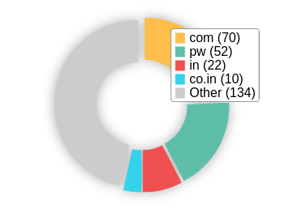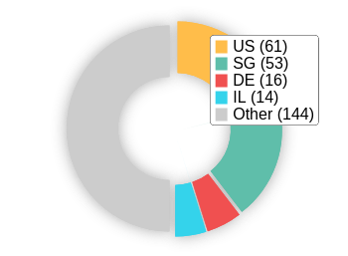Top TLDs Top Countries

# On-Page Link Structure

We found 110 total links. 15% of your links are external links and are sending authority to other sites. 0% of your links are nofollow links, meaning authority is not being passed to those destination pages.

# Friendly Links

Some of your link URLs do not appear friendly to humans or search engines.

We would recommend making URLs as readable as possible by reducing length, le names, code strings and special characters.

Usability

# Your usability could be better



**C**

Your page is OK but could be more usable across devices. Usability is important to maximize your available audience and minimize user bounce rates (which can indirectly a ect your search engine rankings).

# Device Rendering

This check visually demonstrates how your page renders on di erent devices. It is important that your page is optimized for mobile and tablet experiences as today the majority of web tra c comes from these sources.

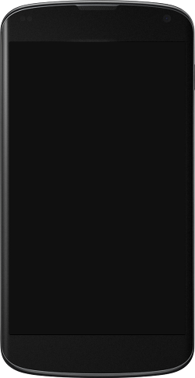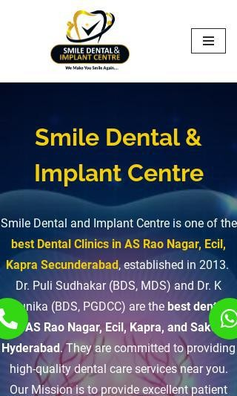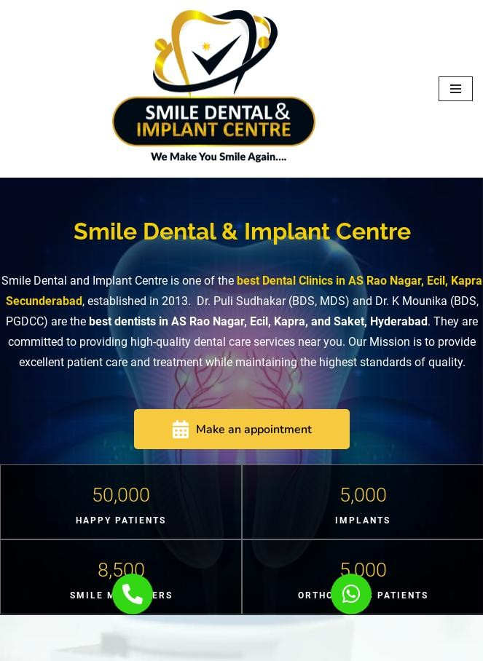

# Google's Core Web Vitals

Google is indicating that they do not have 'su cient real-world speed data for this page' in order to make a Core Web Vitals assessment. This can occur for smaller websites or those that are not crawl- able by Google.

# Use of Mobile Viewports

Your page speci es a viewport matching the device's size, allowing it to render appropriately across devices.

# Google's PageSpeed Insights - Mobile

Google is indicating that your page is scoring poorly on their Mobile PageSpeed Insights evaluation.

Note that this evaluation is being performed from US servers and the results may di er slightly from an evaluation carried out from Google's PageSpeed Web Interface as that reporting localizes to the region in which you are running the report.

Google has indicated that the performance of a webpage is becoming more important from a user and subsequently ranking perspective.



**50**

Lab Data Value

First Contentful Paint 5 s

Opportunities Estimated Savings

Speed Index 9.4 s

Largest Contentful Paint 12.7 s

Serve images in next-gen formats 4.54 s

|  |  |
| --- | --- |
| Eliminate render-blocking  resources | 2.46 s |
| E ciently encode images | 1.62 s |
| Reduce unused JavaScript | 0.65 s |
| Avoid multiple page redirects | 0.63 s |
| Defer o screen images | 0.55 s |
| Reduce unused CSS | 0.32 s |
| Initial server response time was short | 0.25 s |

Time to Interactive 9.8 s

Cumulative Layout Shift 0.01

Total Blocking Time 0.05 s

# Google's PageSpeed Insights - Desktop

Google is indicating that your page is scoring poorly on their Desktop PageSpeed Insights evaluation.

Google has indicated that the performance of a webpage is becoming more important from a user and subsequently ranking perspective.



**79**

Lab Data Value

First Contentful Paint 1.1 s

Opportunities Estimated Savings

Speed Index 2.2 s

Largest Contentful Paint 2.8 s

Time to Interactive 1.1 s

E ciently encode images 0.44 s

Serve images in next-gen

formats

1.04 s

Eliminate render-blocking

resources

0.42 s

Total Blocking Time 0 s

Cumulative Layout Shift 0.017

Avoid multiple page redirects 0.19 s

# Flash Used?

No Flash content has been identi ed on your page.

# iFrames Used?

Your page appears to be using iFrames.

iFrames are discouraged as they can complicate navigation of content in mobile and have historically been harder to index for search engines.

# Favicon

Your page has speci ed a favicon.

# Email Privacy

No email addresses have been found in plain text on your page.

# Legible Font Sizes

The text on your page appears to be legible across devices.

# Tap Target Sizing

The links and buttons on your page appear to be appropriately sized for a user to easily tap on a touchscreen.

Performance Results

# Your performance is good



**A-**

Your page has performed well in our testing meaning it should be reasonably responsive for your users, but there is still room for improvement. Performance is important to ensure a good user experience, and reduced bounce rates (which can also indirectly a ect your search engine rankings).

# Page Speed Info

Your page loads in a reasonable amount of time.

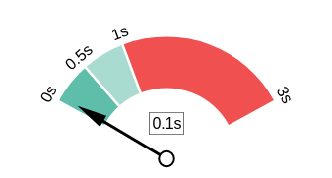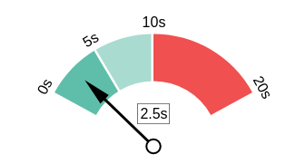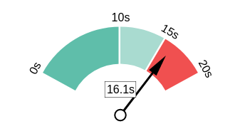Server Response All Page Content Loaded All Page Scripts Complete

# Download Page Size

Your page's le size is reasonably low which is good for Page Load Speed and user experience.

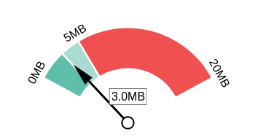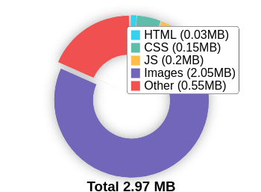Download Page Size Download Page Size Breakdown

# Website Compression (Gzip, Deflate, Brotli)

Your website appears to be using a reasonable level of compression.

Compression Rates Raw Page Size Breakdown

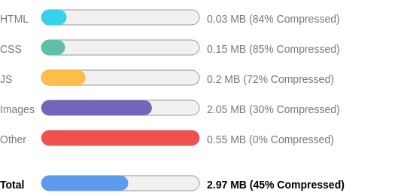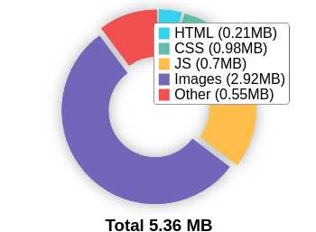

# Number of Resources

This check displays the total number of les that need to be retrieved from web servers to load your page.



**118**

Total Objects

**5**

Number of HTML Pages

**22**

Number of JS Resources

**29**

Number of CSS Resources

**46**

Number of Images

**16**

Other Resources

# Google Accelerated Mobile Pages (AMP)

This page does not appear to have AMP Enabled.

# JavaScript Errors

Your page is not reporting any JavaScript errors.

# HTTP2 Usage

Your website is using the recommended HTTP/2+ protocol.

# Optimize Images

Your page appears to include images which are poorly optimized.

Properly formatting and compressing images can have a signi cant impact on page load performance.

# Minification

All your JavaScript and CSS les appear to be mini ed.

# Deprecated HTML

No deprecated HTML tags have been found within your page.

# Inline Styles

Your page appears to be using inline styles.

Inline styles are an older coding practice and discouraged in favor of using CSS style sheets, due to their ability to degrade page load performance and unnecessarily complicate HTML Code.

Social Results

# Your social is good



**A-**

You have a reasonably good social presence. Social activity is important for customer communication, brand awareness and as a marketing channel to bring more visitors to your website. We recommend that you have all of your pro les listed on your page, and work to build a larger following on those networks.

# Facebook Connected

Your page has a link to a Facebook Page.

# Facebook Open Graph Tags

Your page is using Facebook Open Graph Tags.

# Facebook Pixel

We have not detected a Facebook Pixel on your page.

Facebook's Pixel is a useful piece of analytics code that allows you to retarget visitors if you decide to run Facebook Ads in future.

# Twitter Connected

Your page has a link to a Twitter pro le.

# Twitter Cards

Your page is using Twitter Cards.

# Instagram Connected

Your page has a link to an Instagram pro le.

# LinkedIn Connected

Your page has a link to a LinkedIn pro le.

# YouTube Connected

Your page has a link to a YouTube channel.

**YouTube Activity ** You have a low number of YouTube channel subscribers.

 

**34**

Followers

**8,323**

View Count

Local SEO

# Address & Phone Shown on Website

We can't identify one or both of these components on the page. Missing: Address

Phone +1 949 061 8635

# Local Business Schema

No Local Business Schema identi ed on the page.

# Google Business Profile Identified

No Google Business Pro le was identi ed that links to this website.

# Google Business Profile Completeness

No Google Business Pro le was identi ed that links to this website.

# Google Reviews

No Google Business Pro le was identi ed that links to this website.

Technology Results

# Technology List

These software or coding libraries have been identi ed on your page.

Technology Version



Contact Form 7 5.8.6

 Elementor 3.18.3

 Font Awesome



jQuery

Essential Addons for Elementor

 jQuery Migrate



LiteSpeed

 Litespeed Cache



MySQL

 Neve 3.7.5



PHP 7.4.33

Swiper



WordPress

# Server IP Address

198.54.116.99

# DNS Servers

dns1.namecheaphosting.com dns2.namecheaphosting.com

# Web Server

LiteSpeed

# Charset

text/html; charset=UTF-8